Joel Mayner

Goldsmiths Map App – Design

**Intro**

The campus had a reputation for being hard to navigate which became somewhat of a running joke for Students, Teachers and

**Aim**

The priority of the project was to help users navigate the Richard Hoggart Building itself, which was the primary feature of what would be known as the project’s “core build”, with the rest of the campus as a lower priority. As Eduroam can be erratic at times depending on the user’s location, it was decided to allow the app to function offline. Also considering time constraints and other logistical limitations, the app would be developed exclusively for Android devices using the android studio, this would compliment the group’s course’s focus on the Java programming language and decrease the amount of work needed. A rudimentary A* algorithm would be used to navigate between the campus rooms. Once the basics were in place, accessibility had come up as a legitimate issue for navigating the campus: When it came to programming, the application had to account for those who had difficulty using stairs, so a function for filtering out stairs and emphasising lifts and ramps was coded in.

All the user would have to do is find and select which room they were in, and which room they wanted to go to and toggle the accessibility filter. The app will display a route between rooms, displayed with a sequence of lines guiding the user from one room to another.

**Alterations**

Very little changed in the time between developing the core idea to the proposed implementation. But of the few changes, a prominent one was the decision to add a feature to view and look around the map freely. The research carried out had the effect of justifying most of the decisions made during the development phase.

The biggest major change to the app was the implementation of Fire exit access, which required adding another filter option in addition to accessibility.

**Core**

RHB –

The RHB building can be intimidating for new students, visitors and newcomers, its corridors are unintuitive, and its routes are remembered rather than figured out, more than any other building on campus, it is the Richard Hoggart Building where people got lost. Although the ground floor is a straightforward location with relatively few trouble spots, the upper floors were where navigation would get confusing.

The main campus map was considered an important feature, even if it was not as vital to the implementation of the RHB building. As a relatively simple map, it would allow users to get almost anywhere on campus.

**Addendum**

The addendum build consisted of a list of items that were desirable but not considered vital if the group could not continue to develop beyond the core build the intent was for others to be able to add to the project.

GPS, room bookings implementation, map layouts for other buildings

**Development**

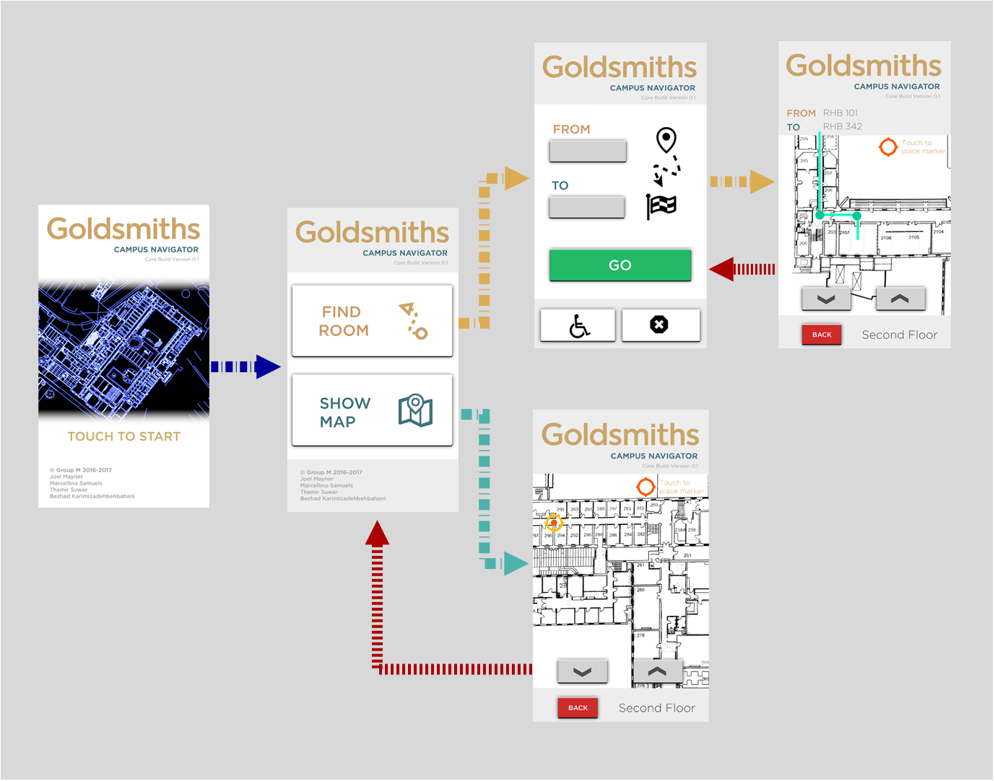

The design was intended to be clear and simple. The colour scheme was designed to complement the university’s font colour (with help from <http://paletton.com/> for reference) All the icons were open source and chosen for their recognisability. The user can pan and zoom in and out while viewing the map.

**Implementation**

Developing for the Android development studio was challenging, due not only to the group's unfamiliarity with the development studio environment but especially because of its reliance on the interactions between XML and Java code. The footprint of a single function, class or “activity” was considerably large, requiring the management of multiple and disparate files in the project directory for every single feature added. To compound development further, several inconsistencies and errors manifested within the Development environment itself, such as vanishing import statements and a deceptively unintuitive XML graphical UI. With the Graphical User Interface, adding a single element (such as a button or text field) unleashed a deluge of over-automated pre-sets which greatly restricted what lines could be added or removed without causing an error.

**References**

<http://paletton.com/>

**https://www.iconfinder.com/**